

GARRETT COLLEGE ATHLETICS
EMERGENCY ACTION PLAN
Update September 1, 2023

Participation in sports is inherently dangerous. Emergency situations will arise at some point during sport activities. The ability to handle and contain these situations is paramount to the health, safety and well- being of all parties involved. The main concern of emergency aid is to maintain cardiovascular function, and indirectly, central nervous system function. The key to emergency aid in the athletic setting is the initial evaluation of the emergent situation. Time is critical, so this evaluation must be done rapidly and accurately so that proper aid can be rendered appropriately and without delay.

Conditions that constitute Medical Emergencies include but are not limited to:
- An unconscious athlete
- Compromised breathing or circulation
- Seizure
- Abnormality of bones and joints
- Trauma to the head or spinal column
- Heat / Cold Symptoms
- Severe Asthma or Allergic Reactions

IF YOU ARE IN DOUBT, BE SAFE AND CALL 911

Emergency Phone Numbers
Ambulance Service | 911
Fire Department | 911
Local Police | 911
Maryland State Police | 301-387-0482
Poison Control | 1-800-222-1222
Campus Security | 240-321-5799
Garrett Regional Medical Center | 301-533-4000
 | 541 North 4th Street Oakland, MD 21550

** Remember when dialing an outside line from a campus phone you must dial 8 first **

Garrett College Emergency Contacts

Garrett College Security 240-321-5799 (M)

Elizabeth Show, Co-Athletic Director & Head Athletic Trainer 301-387-3053 (O)
724-322-2419 (M)

Eric Hallenbeck, Co-Athletic Director & Head Baseball Coach 301-387-3331 (O)
301-616-6250 (M)

Rick Ray, Assistant Athletic Trainer 301-387-3150 (O)
304-552-1182 (M)

General Emergency Procedure – Certified Athletic Trainer Present

It is the responsibility and duty of all individuals involved in the college’s athletics to be able to initiate emergency action procedures in the instance when a student-athlete is injured. When a Garrett College athletic team has a scheduled in-season practice or competition, the Garrett College Athletic Trainer should see that appropriate emergency equipment is made readily available and accessible and that emergency procedures be implemented and practiced to provide the best possible care for the injured individual. The athletic trainer will direct immediate emergency response.

When a student athlete is injured and deemed in need of emergency medical services, the following plan of action should be implemented:
- A member of the Garrett College coaching staff or athletic trainer should call 911 to initiate emergency action procedures from the nearest available phone or cell phone.
- The caller shall relay all appropriate information and not disconnect the call until the EMS operator has all required information. This information includes:
  - Type of emergency situation
  - Type of suspected injury
  - Present condition of the student-athlete
  - Current assistance being provided (i.e. CPR)
  - Location and number of phone calling from

950 | CARC Gym | 65 Laker Drive, McHenry MD 21541
1500 | Wrestling Facility/Clubhouse | 142 Laker Drive, McHenry MD 21541
1600 | Batting/Practice Facility | 158 Laker Drive, Mc Henry MD 21541
N/A | Baseball/Softball/Soccer Complex | 687 Mosser Road, McHenry MD 21541

  - Exact location of the student-athlete (provide a landmark)
- The caller will then inform the on-site personnel that an ambulance has been dispatched and position themselves to direct the ambulance and emergency personnel to location of the emergency. ** Remember that many of the doors to campus buildings are locked **
- If a campus security officer is not present a member of the GC staff will call and request that a member of security be dispatched to the site. (1-240-321-5799)
- Establish a safety zone. Delegate coaching staff members and support personnel for crowd control, first aid assistance etc.
- The Garrett College athletic trainer shall then assist the ambulance service staff in preparing the injured person for transportation to the nearest emergency facility.
- A member of the Garrett College coaching staff (or parent/guardian if present) shall accompany the injured person to the nearest medical facility. The traveling member will bring the following items:
  - Medical History Questionnaire
  - Athlete’s Insurance Information
- Notify one or both of the athletic directors (if not present)
  - Elizabeth Show 301-387-3053 (O)
  - Eric Hallenbeck 301-387-3331 (O)
  - Athletic directors will contact the student-athlete parent or guardian as necessary
- Document the athlete’s injury and emergency procedures taken.

General Emergency Procedure – No Certified Athletic Trainer Present

It is the responsibility and duty of all individuals involved in Garrett College athletics to be able to initiate emergency procedures in the instance when a student-athlete is injured and there is no Athletic Trainer present. When a Garrett College athletic team practices without the on-sight coverage of an Athletic Trainer, the coaching staff should see that appropriate emergency equipment is made readily available and accessible and that emergency procedures be implemented and practiced to provide the best possible care for the injured individual.

When a student athlete is injured and deemed in need of emergency medical services, the following plan of action should be implemented:
- A coach, or designee should call 911 to initiate Emergency Action Procedures from the nearest available phone or cell phone.
- The caller shall relay all appropriate information and not disconnect the call until the EMS operator has all required information. This information includes:
  - Type of emergency situation
  - Type of suspected injury
  - Present condition of the student-athlete
  - Current assistance being provided (i.e. CPR)
  - Location and number of phone calling from

950 | CARC Gym |  |  | 65 Laker Drive, McHenry MD 21541
1500 | Wrestling Facility/Clubhouse |  |  | 142 Laker Drive, McHenry MD 21541
1600 | Batting/Practice Facility |  |  | 158 Laker Drive, Mc Henry MD 21541
N/A | Baseball/Softball/Soccer Complex |  |  | 687 Mosser Road, McHenry MD 21541

  - Exact location of the student-athlete (provide a landmark)
- The same caller will then call security and request that a member of security be dispatched to the site. Phone Number: (1-240-321-5799)
- The caller will then inform the on-site personnel that an ambulance has been dispatched and position themselves to direct the ambulance and emergency personnel to location of the emergency. ** Remember that many of the doors to campus buildings are locked **
- A member of the coaching staff will call the athletic trainers and inform them of the circumstances.
  - Elizabeth Show 301-387-3053 (O); 724-322-2419 (M)
  - Britta Lais 301-387-3150 (O); 412-477-0537 (M)
- The coaching staff shall then assist the ambulance service staff in preparing the injured person for transportation to the nearest emergency facility.
- A member of the Garrett College coaching staff shall accompany the injured person to the nearest medical facility. The traveling member will bring the following items:
  - Medical History Questionnaire
  - Athlete’s Insurance Information
- Notify one or both of the athletic directors (if not present)
  - Elizabeth Show 301-387-3053
  - Eric Hallenbeck 301-387-3331
  - Athletic directors will contact the student-athlete parent or guardian as necessary
- Document the athlete’s injury and emergency procedures taken.

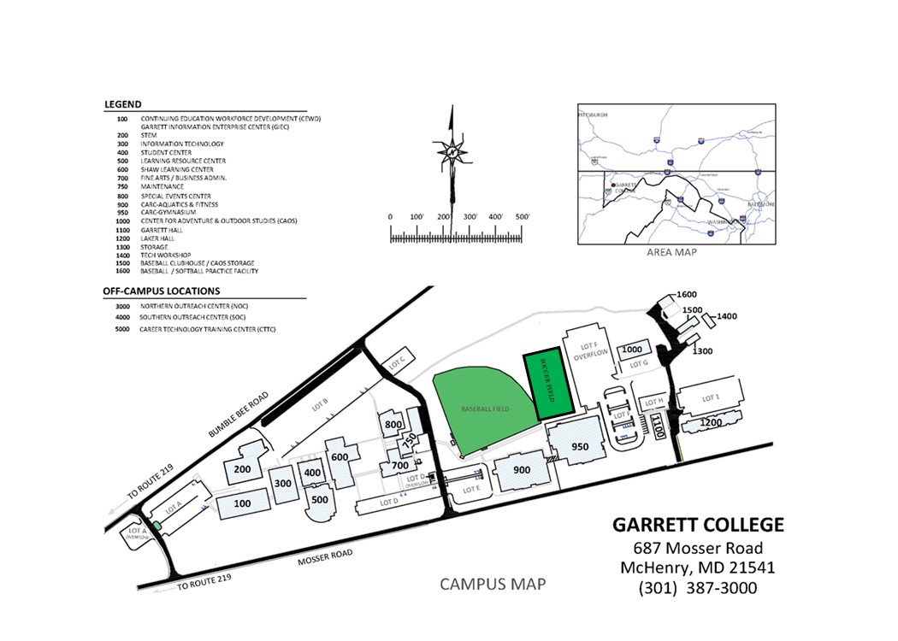

CARC Gymnasium – 695 Mosser Road McHenry, MD 21541

950 | CARC Gym |  |  | 65 Laker Drive, McHenry MD 21541
1500 | Wrestling Facility/Clubhouse |  |  | 142 Laker Drive, McHenry MD 21541
1600 | Batting/Practice Facility |  |  | 158 Laker Drive, Mc Henry MD 21541
N/A | Baseball/Softball/Soccer Complex |  |  | 687 Mosser Road, McHenry MD 21541

AED Locations:
- Portable with Athletic Trainer
- On wall outside main CARC main gym (Room #970)
- Hallway between Wrestling Room & Clubhouse Entrance (Building #1500)

GARRETT COLLEGE LIGHTNING POLICY

Athletic Trainer, Athletic Administrator, and/or game officials shall make the decision when to remove individuals from the field in the case of a lighting emergency. In the absence of all of the above, coaches will be responsible to remove athletes from the field and adhere to the following protocol.

Athletic personnel will monitor local forecasts and weather warnings to check for signs of threatening weather and determine if an event needs to be postponed or cancelled.

Play will be suspended and all players, spectators, and athletics personnel will leave the field at the first sign of lightning.

Players and athletics personnel will seek a primary shelter consisting of a permanent structure with electrical/ telephone wiring/ plumbing. In the event that a primary structure is unavailable players and personnel should seek a structure with a roof, and closed windows (i.e. a vehicle)

Players and athletics personnel are advised to avoid being in close proximity to the highest point of an open field or on open water. Do not take shelter near trees, flagpoles, or light poles.

If caught in an open field, with no shelter nearby, assume the lightning safe position (crouched down with balls of feet in contact with the ground, feet together, arms wrapped around your knees, head lowered, ears covered.

You must wait 30 minutes until after the last sight of lightning or sound of thunder in order to resume activities. (i.e. if you are at minute 29 and another flash of lightning occurs, the time of 30 min. starts over)

Sport-Specific Lightening Procedures:
- Baseball/Softball: Garrett College athletes will go into the Maintenance Bay. Visiting athletes should return to their bus.
- Soccer: Garrett College athletes will go into Locker Room in CARC Gymnasium. Visiting athletes should return to their bus.

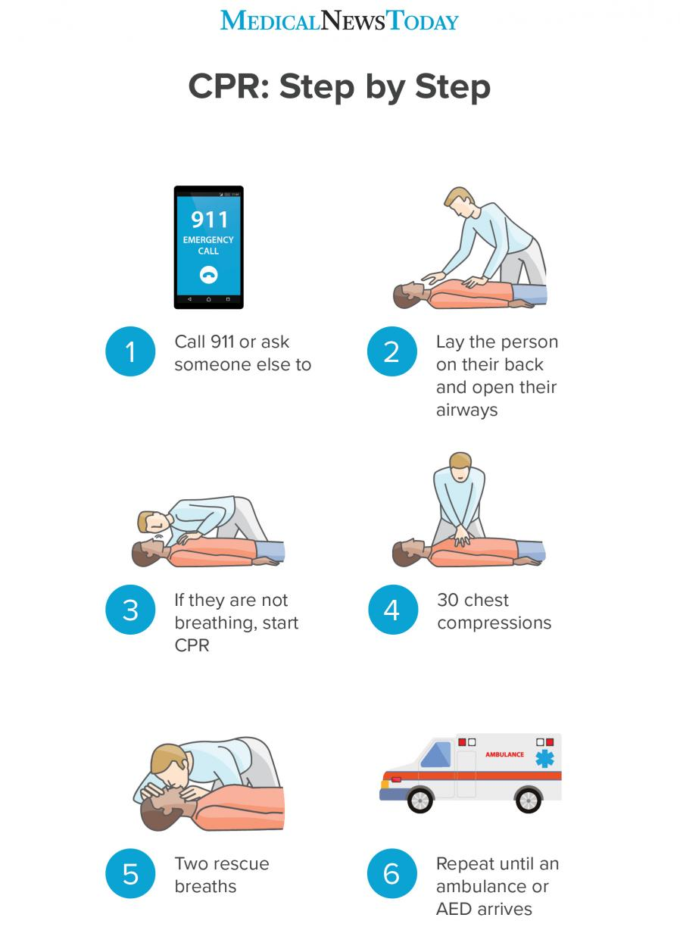
https://www.medicalnewstoday.com/articles/324712

CARC GYMNASIUM- SITE SPECIFIC INFORMATION
Telephone Locations:
- Athletic Training Room
- Laundry Room
AED Locations:
- Fixed to wall outside of gymnasium next to room 975
- Portable with AT
- Security
Key Locations:
- Garrett College Campus Security
- Garrett College Coaching Staff
- Athletic Trainer
Gate Locations:
- None
Preferred Route for EMS:
- Laker Drive Entrance to CARC Gymnasium from Mosser Road
Lightning / Weather Safe Location:
- Interior Hallway, away from windows and doors
- Locker Rooms

BASEBALL FIELD- SITE SPECIFIC INFORMATION
Telephone Locations:
- Athletic Training Room
- Cell Phones
AED Locations:
- Fixed to wall inside of CARC fitness center
- Fixed to wall outside of CARC gymnasium 975
- Portable with AT
- Campus Security
Key Locations:
- Garrett College Campus Security
- Garrett College Coaching Staff
- Athletic Trainer
Gate Locations:
- None
Preferred Route for EMS:
- Entrance to Baseball/Softball/Soccer Complex in front of CARC from Mosser Road
Lightning / Weather Safe Location:
- In maintenance bay (home team only)
- Inside CARC
- Interior Hallways, Locker Rooms, away from windows and doors
- Return to bus (visiting team)

BATTING CAGES- SITE SPECIFIC INFORMATION
Telephone Locations:
- Portable Cell Phones
AED Locations:
- Breezeway between Wrestling room & Baseball club house (bldg. 1500)
- Security
Key Locations:
- Garrett College Campus Security
- Garrett College Coaching Staff
- Athletic Trainer
Gate Locations:
- None
Preferred Route for EMS:
- Entrance to Building from Laker Drive off of Mosser Road

